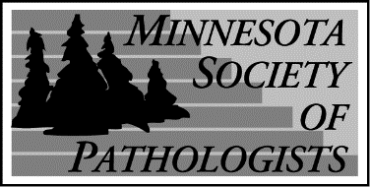

Minnesota Society of Pathologists Fall Seminar
"Intraoperative Frozen Section Consultation - Practical Approach, Challenges and Limitations"
November 11, 2023
8:00 am- 1:00 pm

McNamara Alumni Center
200 Oak Street
Minneapolis, MN 55455

Course Directors:
Mahmoud Khalifa, MD, PhD
Emil Racila, MD
Department of Laboratory Medicine and Pathology
University of Minnesota, Minneapolis, MN

7:15 AM | Registration and Visit with Exhibitors
8:00-8:45 AM | The Frozen Section Practice at Mayo Clinic: The Past, Present and Future | Gary Keeney, M.D
8:50-9:25 AM | Navigating the Freeze on the Hot Seat: What We Have Learned in GI Intraoperative Consultations | David Cartwright, M.D.
9:30-10:10 AM | Navigating the Freeze on the Hot Seat: What We Have Learned in GI Intraoperative Consultations | Oyedele Adeyi, M.D.  Areeba H. Rizvi, M.D.
10:15-10:35 AM | Mid-Morning Break and Visit with Exhibitors
10:35-11:25 AM | Intraoperative Assessment of GYN Tract Neoplasms | Molly Klein, M.D.
11:30 AM-1:00 PM | Minnesota Society of Pathologists Business Meeting and Lunch  President: Mahmoud Khalifa, MD  Presentation of the 2023 Distinguished Pathologists Award to Claudia Cohn, MD
1:00 PM | Adjourn

After completion of the evaluation form, CME certificates will be sent by November 25th. The evaluation link is: https://www.surveymonkey.com/r/QBQLWX8 .

